Segmentation

Segmentation is another memory management technique that gives the user's view of a process. The user's view is mapped into the Physical Memory. In Segmentation, a process is divided into multiple segments. The size of each segment is not necessarily the same which is different from paging

Segmentation and Paging
In Paging, we break a process address space into blocks known as pages. In the case of Segmentation, we break a process address space into blocks known as sections. Memory Size. The pages are blocks of fixed size. The sections are blocks of varying sizes.

Segmentation in Detail--
The segmentation technology is used in operating systems and the process is divided into many pieces called segments and these segments are of variable size. In this, segmentation uses a variable partitioning method: one segment is equal to one complete memory block. The access and details of each segment, they are stored in a segment table consisting of two fields. The base field gives the starting address from which other addresses get access and the limit field returns the length of the section.
A segment can be defined as a logical grouping of instructions such as an array. Subroutine, function, local variable, stacks, blocks, and symbol table. Segmentation is the technique for managing these segments.

Process for converting Logical address into Physical address
- The logical address will be extensively used in the memory management process and it is composed of segment number which ranges from 0 to 99 and the offset.
- Based on the length there may be two cases
Case-1 − When the offset value is greater than or equal to the limit
Case-2 − When the offset value is less than the limit.

Why Segmentation is used?
The primary purpose of using segmentation is to increase the security and protection of the segments. It manages each divided segment and allows only one process to access the segment preventing too many processes
The Segmentation technique is used for memory allocation in Operating systems which partitions the program into different parts. The divided segments are identified using the sequence number and it is maintained by the segment table for easy access. The segment table is used to map the segment numbers to the actual memory locations of its storage.

Implementation of Segmentation
Let us now see the implementation of segmentation. As we know in segmentation the user program is divided into the number of segments. And a segment is identified by two components i.e. a segment name and segment offset.
In this section, we will see how this two-dimensional address is mapped onto the one-dimensional physical memory. Like we have page table in paging similarly we have a segment table in segmentation.

Segmentation Table
The segment table has two entries for each segment i.e. segment base address and segment limit. The segment base address denotes the starting address where the segment is stored in the memory while the segment limit denotes the length of the segment.
Let us understand the workflow of the segment table with the help of the figure given below.
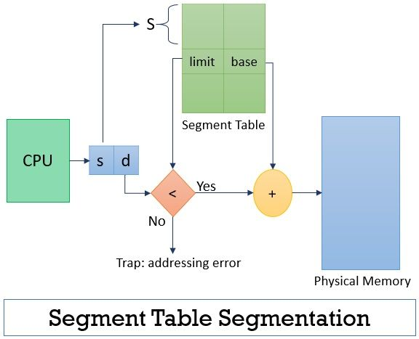
As in the figure above you can see that the CPU calls outs for a segment and logically provides a two-dimensional address for that segment where the first entity s is the segment number (segment name) and its offset d.
Now the segment number would help to find two more details regarding the segment number in segment table i.e. segments base address and its limit. On the other hand, the offset provides by CPU is verified whether it is between 0 and the limit of called segment if yes then the offset is added to the base address of called segment to retrieve the physical address of the segment. If the offset doesn’t verify the condition the operating system is trapped with addressing error i.e. the logical address tries to attempt beyond the segment limit.

Example of Segmentation in OS
Consider that a user program has been divided into five segments and they are numbered from segment 0 to segment 4, as you can see them in the logical address space. You also have a segment table which has entries for these segment with their base address in physical memory and their limit.
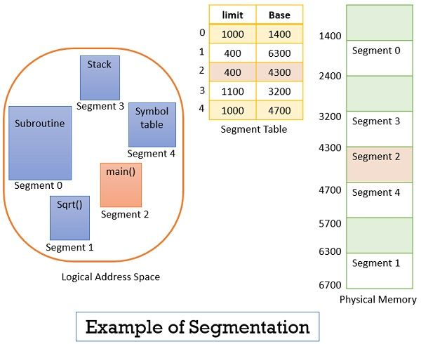
Now suppose the CPU calls for segment number 2 which is 400 bytes long and it resides at 4300 memory location. The CPU wants to refer the 53rd byte of segment 2. So, here the input we get from CPU is segment number 2 and 53 as an offset.
Now the offset is in between 0 and limit of the segment 2 i.e. 400. So, the condition got verified and the offset is being added to the base address of the segment 2 to reach the 53rd byte of the segment 2 in physical memory. In case you try to access the 453rd byte of segment 2 then it would result in a trap to the operating system as offset value 453 is greater than the limit of segment 2.

Advantages and Disadvantages
Advantages of Segmentation
- Segmentation is more close to the programmer’s view of physical memory.
- Segmentation prevents internal fragmentation.
- Segmentation prevents the CPU overhead as the segment contain an entire module of at once.
- Segments are of variable size.

Disadvantages of Segmentation
1-The segmentation leads to external fragmentation.
2-Maintaining a segment table for each process leads to overhead
3-This technique is expensive.
4-The time is taken in order to fetch the instruction increases since now two memory accesses are required.
5-Segments are of unequal size in segmentation and thus are not suitable for swapping.

Segmentation Fault
The Segmentation fault can be noticed in two different ways when the method of handling is wrong and when any unauthorized program tries to use the segments in the Operating system.

Operating System - Virtual Memory

A computer can address more memory than the amount physically installed on the system. This extra memory is actually called virtual memory and it is a section of a hard disk that's set up to emulate the computer's RAM.
Virtual Memory is a space where large programs can store themselves in form of pages while their execution and only the required pages or portions of processes are loaded into the main memory. This technique is useful as a large virtual memory is provided for user programs when a very small physical memory is there. Thus Virtual memory is a technique that allows the execution of processes that are not in the physical memory completely.
The main visible advantage of this scheme is that programs can be larger than physical memory. Virtual memory serves two purposes. First, it allows us to extend the use of physical memory by using disk. Second, it allows us to have memory protection, because each virtual address is translated to a physical address.
Following are the situations, when entire program is not required to be loaded fully in main memory.

Virtual Memory mainly gives the illusion of more physical memory than there really is with the help of Demand Paging.
In real scenarios, most processes never need all their pages at once, for the following reasons :
- Error handling code is not needed unless that specific error occurs, some of which are quite rare.
- Arrays are often over-sized for worst-case scenarios, and only a small fraction of the arrays are actually used in practice.
- Certain features of certain programs are rarely used.

In an Operating system, the memory is usually stored in the form of units that are known as pages. Basically, these are atomic units used to store large programs.
Virtual memory can be implemented with the help of:-
- Demand Paging
- Demand Segmentation

Need of Virtual Memory
Following are the reasons due to which there is a need for Virtual Memory:
- In case, if a computer running the Windows operating system needs more memory or RAM than the memory installed in the system then it uses a small portion of the hard drive for this purpose.
- Suppose there is a situation when your computer does not have space in the physical memory, then it writes things that it needs to remember into the hard disk in a swap file and that as virtual memory.

Modern microprocessors intended for general-purpose use, a memory management unit, or MMU, is built into the hardware. The MMU's job is to translate virtual addresses into physical addresses. A basic example is given below −
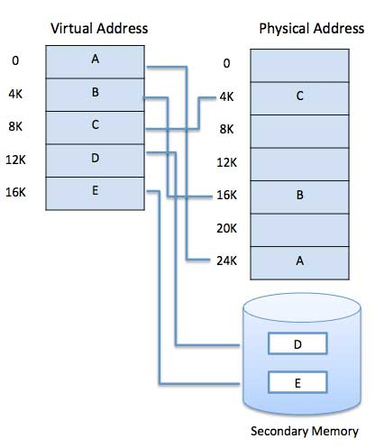

Virtual memory is commonly implemented by demand paging. It can also be implemented in a segmentation system. Demand segmentation can also be used to provide virtual memory.

Demand Paging
A demand paging system is quite similar to a paging system with swapping where processes reside in secondary memory and pages are loaded only on demand, not in advance. When a context switch occurs, the operating system does not copy any of the old program’s pages out to the disk or any of the new program’s pages into the main memory Instead, it just begins executing the new program after loading the first page and fetches that program’s pages as they are referenced.
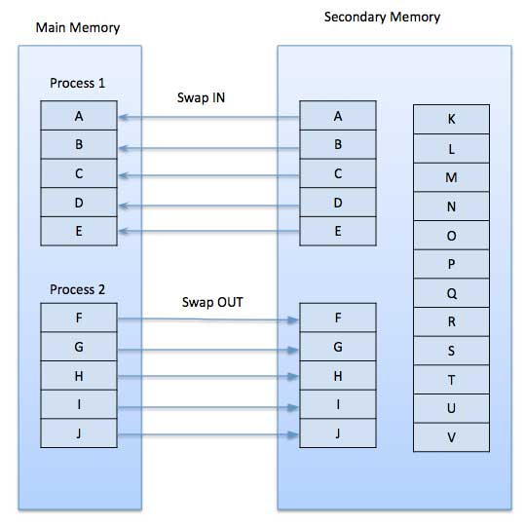
While executing a program, if the program references a page which is not available in the main memory because it was swapped out a little ago, the processor treats this invalid memory reference as a page fault and transfers control from the program to the operating system to demand the page back into the memory.
Advantages of Virtual Memory
- The degree of Multiprogramming will be increased.
- User can run large application with less real RAM.
- There is no need to buy more memory RAMs.

Disadvantages of Virtual Memory
- The system becomes slower since swapping takes time.
- It takes more time in switching between applications.
- The user will have the lesser hard disk space for its use.

Demand Paging
Demand paging in os is a technique in which pages are loaded from disk into main memory only when they are needed, i.e., demanded by the program. This technique allows the operating system to save memory space by keeping only those pages in main memory that are currently required by the program.
As a result, it reduces the cost of memory allocation and provides better memory utilization. However, the initial access time for pages that are not already in memory can cause a delay in the program’s execution.
Pre-paging, on the other hand, is a technique in which the operating system loads multiple pages into main memory before they are actually demanded by the program. This technique is based on the assumption that if one page is needed, there is a good chance that the pages adjacent to it will also be needed soon. Pre-paging can improve the program’s execution speed as it reduces the delay caused by demand paging. However, it can also result in unnecessary memory allocation and memory wastage.
In summary, demand paging in os and pre-paging are both useful memory management techniques, but they differ in their approach. demand paging is efficient in terms of memory utilization, while pre-paging is efficient in terms of execution speed. The choice of which technique to use depends on the specific requirements of the program and the available memory resources.

The Impact of Demand Paging in Os on Virtual Memory management
Demand paging in os is a technique used in virtual memory management that enables a computer to use its physical memory more efficiently.
only the necessary parts of a program are loaded into the memory, rather than the entire program, which reduces the amount of physical memory required by the system.
Allows the operating system to swap memory pages between the main memory and the secondary storage based on demand.

When an application needs to access a page that is not currently in the main memory, the operating system retrieves that page from the secondary storage and places it in the main memory. This process is known as page fault.

The impact of demand paging on virtual memory management is significant. It allows the operating system to use virtual memory efficiently, which in turn improves the overall performance of the system.

The main advantage of demand paging is that it reduces the amount of physical memory required by the system. This enables the system to run more applications concurrently and makes it possible to run larger programs than would otherwise be possible.

Working Process of Demand Paging

So, let’s understand this with the help of an example. Suppose we want to run a process P which has four pages P0, P1, P2, and P3. Currently, in the page table, we have pages P1 and P3.
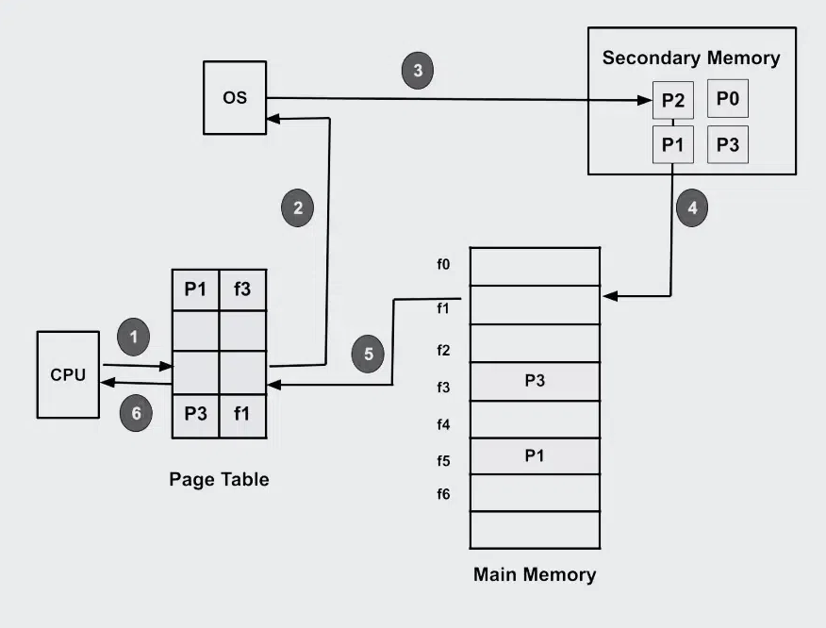

Demand Paging
So there are some steps that are followed in the working process of the demand paging in the operating system.
- Program Execution: When a program starts, the operating system creates a process for the program and allocates a portion of memory to the process.
- Creating page tables: The operating system creates page tables for processes, which track which program pages are currently in memory and which are on disk.
- Page fault handling: A page fault occurred when the program attempted to access a page that is not currently in memory. The operating system interrupts the program and checks the page tables to see if the required page is on disk.
- Page Fetch: If the required page is on disk, the operating system fetches the page from the disk and loads it into memory.
The page table is then updated to reflect the page’s new location in memory.
- Resuming the program: Once the required pages have been loaded into memory, the operating system resumes execution of the program where it left off. The program continues to run as if the page had always been in memory.
- Page replacement: If there is not enough free memory to hold all the pages a program needs, the operating system may need to replace one or more pages currently in memory with pages currently in memory. on the disk. The page replacement algorithm used by the operating system determines which pages are selected for replacement.
- Page cleanup: When a process terminates, the operating system frees the memory allocated to the process and cleans up the corresponding entries in the page tables.

Qst-What is Page Fault in Demand Paging ?

When the requested page is not available in memory then this situation is known as page Fault.

Qst -What happens if the process tries to access a page that was not brought into memory?
Access to a page marked invalid causes a page fault.

Qst- How does demand paging differ from swapping?
Demand paging is a method for loading only the necessary parts of a program into RAM as needed, while swapping involves moving entire processes in and out of RAM. Demand paging is more granular and efficient.

Qst- What happens during a page fault?
When a page fault occurs, the operating system:
Identifies the missing page.
Retrieves it from secondary storage.
Updates the page table to reflect the new location in RAM.
Resumes the interrupted process.

Qst- What are some strategies to optimize demand paging?
Use efficient page replacement algorithms.
Adjust the size of the page file or swap space.
Ensure sufficient physical memory to reduce page faults.
Profile and optimize applications to minimize memory usage.

Benefits of the Demand Paging

So in the Demand Paging technique, there are some benefits that provide efficiency of the operating system.
- Efficient use of physical memory: Query paging allows for more efficient use because only the necessary pages are loaded into memory at any given time.
- Support for larger programs: Programs can be larger than the physical memory available on the system because only the necessary pages will be loaded into memory.
- Faster program start: Because only part of a program is initially loaded into memory, programs can start faster than if the entire program were loaded at once.
- Reduce memory usage: Query paging can help reduce the amount of memory a program needs, which can improve system performance by reducing the amount of disk I/O required.

Drawbacks of the Demand Paging

- Page Fault Overload: The process of swapping pages between memory and disk can cause a performance overhead, especially if the program frequently accesses pages that are not currently in memory.
- Degraded performance: If a program frequently accesses pages that are not currently in memory, the system spends a lot of time swapping out pages, which degrades performance.
- Fragmentation: Query paging can cause physical memory fragmentation, degrading system performance over time.
- Complexity: Implementing query paging in an operating system can be complex, requiring complex algorithms and data structures to manage page tables and swap space.

Performance of Demand Paging
Demand paging is a memory management technique used by operating systems to optimize memory usage. In demand paging, only the required pages of a program are loaded into memory when needed, rather than loading the entire program at once. This helps to reduce memory wastage and improve overall system performance.
The performance of demand paging is often measured in terms of the effective access time. Effective access time is the amount of time it takes to access memory, if the cost of page faults are amortized over all memory accesses. In some sense it is an average or expected access time.

The EAT depends on the probability of a page fault (p), the memory access time (m), and the page fault service time (s).
The formula is EAT = (1-p) * m + p * s. The lower the EAT, the better the performance of demand paging.

Advantages. Demand paging, as opposed to loading all pages immediately: Only loads pages that are demanded by the executing process. As there is more space in main memory, more processes can be loaded, reducing the context switching time, which utilizes large amounts of resources.

